Ivonne Santoyo-Orozco
Architectural Association School of Architecture

O’Gorman, Juan (1905-1982)

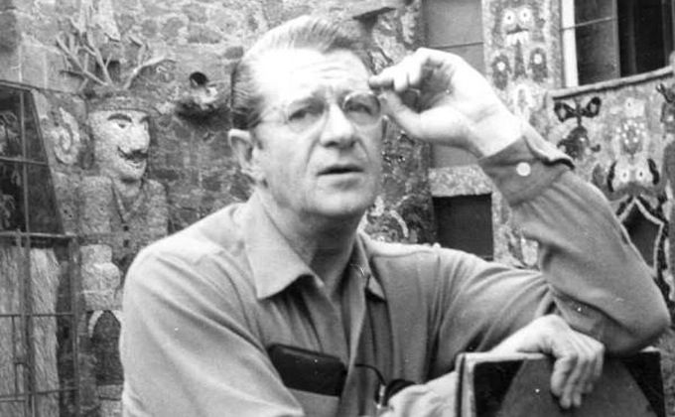
Juan O’Gorman
http://www.revistacodigo.com/juan-o-gorman/

Perhaps the best way to understand the mexican architect and painter, Juan O’Gorman, is through his self-portrait of 1950 in which he depicts himself in multiple frames corresponding to his different occupations. Juan O’Gorman was born in Mexico City of Irish descent. He graduated in 1927 from the School of Architecture of the National Autonomous University of Mexico and began his career working as a draftsman in the studio of Obregón, Tarditi and Villagrán García (1921-1925), and later on, as an architect for Carlos Obregón Santacilla (1925-1928). At a very early age, O’Gorman designed the first functionalist houses in Mexico (1929), the most representative of this being the House-Studio of Diego Rivera (1931). For him, functionalism was to be understood as the tendency to design architecture as a work of engineering, which he understood as maximum efficiency and minimum maintenance. However, in time his designs moved towards an organic formalism influenced by the work of Frank Lloyd Wright, Antonio Gaudí and Ferdinand Cheval, exemplified most explicitly in his house-studio in San Jeronimo (1951). Around the same time, he also designed the Central Library of the National Autonomous University Campus in the south of Mexico City, a piece that can be considered representative of O’Gorman’s various aesthetic interests: an efficently organised slab, whose massive 4000 sqm facade is a continuous stone and glass mozaic expressing a political and social history of Mexico. This shift was separated by around 10 years (1939-1949) in which O’Gorman grew increasingly critical of the architecture profession, arguing that the architects of his time were becoming little more than businessmen. As such, he distanced himself from the profession to invest his time in painting.

As a painter, he worked closely with Antonio M. Ruiz and was influenced by the painters Franciso Goitia, José María Velasco, Frida Kahlo, Diego Rivera, Atl, Jose Clemente Orozco and David Alfaro Siquieros. His paintings are commonly situated either belonging to the school of mexican realism or to what some have referred to as mexican renaissance. However, amongst the various movements, O’Gorman developed his own style. His most common subjects were landscapes, portraits and historical narratives. His landscapes were at times fantastic, and at other times realistic. They seem to capture traces of his observations during the few years of time he spent in Guanajuato as a child. His portraiture, apart from a selection of self-portraits, mainly depicted his friends. And while O’Gorman painted a huge variety of historical narratives in his murals, he had a particularly keen interest in interpreting the Mexican Independence, the Revolution and Pre-Columbian culture.

Painting provided O’Gorman with a means by which to express his critical insights in a more direct manner. He was a believer in social reform and he saw in his work a medium through which to communicate his ideas. Yet O’Gorman’s views were at times controversial. For example, a mural located in the old Mexico City airport entitled “The Conquest of Air by Man” (1937) was censored because the authorities argued that it displayed anti-fascist sympathies as well as opposition to religious fanaticism. In spite of this, his work has been widely appreciated, and has been honoured with several awards, among which is the National Prize for Arts (1972).

Selected Works:
1931. House-Studio Diego Rivera in Mexico City.
1937. “The Conquest of Air by Man”, Mural at the old Mexico City airport.
1941. “The History of Michoacan”. Mural in Library Gertrudis Bocanegra in Pátzcuaro, Michoacan, Mexico
1943. “Recuerdo de los remedios”. Tempera Painting 50.5 x 75.8cm.
1950. Self-portrait.
1951. Central Library of the National Autonomous University Campus in the south of Mexico City (In collaboration with Gustavo Saavedra y Juan Martínez de Velasco).
1952. O’Gorman’s house San Jeronimo, San Angel, Mexico City, Mexico
1960. “Retablo de la Independencia”, Mural in the National Museum of History at the Chapultepec Castle, Mexico City.
1965. “Credit transforms Mexico”. Mural in the International Bank in Reforma, Mexico City.

References and further reading:
Luna Arroyo, Antonio. (1973) Juan O’Gorman: Au- tobiografía, Antología, Juicios Críticos y Documen- tación Exhaustiva sobre su Obra, Mexico City: Cuadernos Populares de Pintura Mexicana Moderna.
Rodríguez Prampolini, Ida. (1983) Juan O’Gorman, arquitecto y pintor, Mexico City: Universidad Nacional Autónoma de México.
Guzmán Urbiola, Xavier (2007) Juan O’Gorman: Sus Primeras Casas Funcionales, Mexico City: UNAM.

Visual Material:
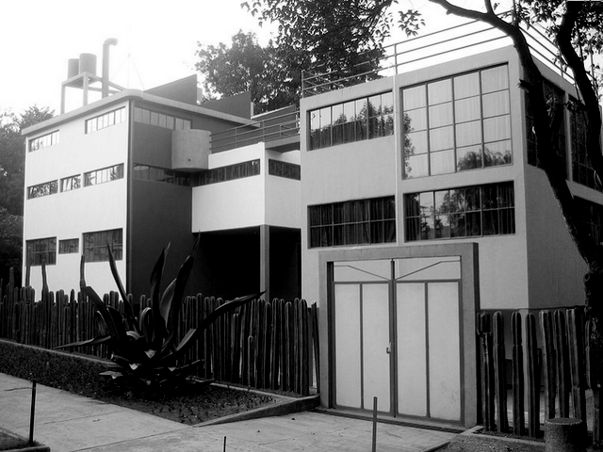
House-Studio Diego Rivera in Mexico City.
1931
http://www.archdaily.mx/46931/clasicos-de-arquitectura-museo-casa-estudio-diego-rivera-y-frida-kahlo-juan-o´gorman/

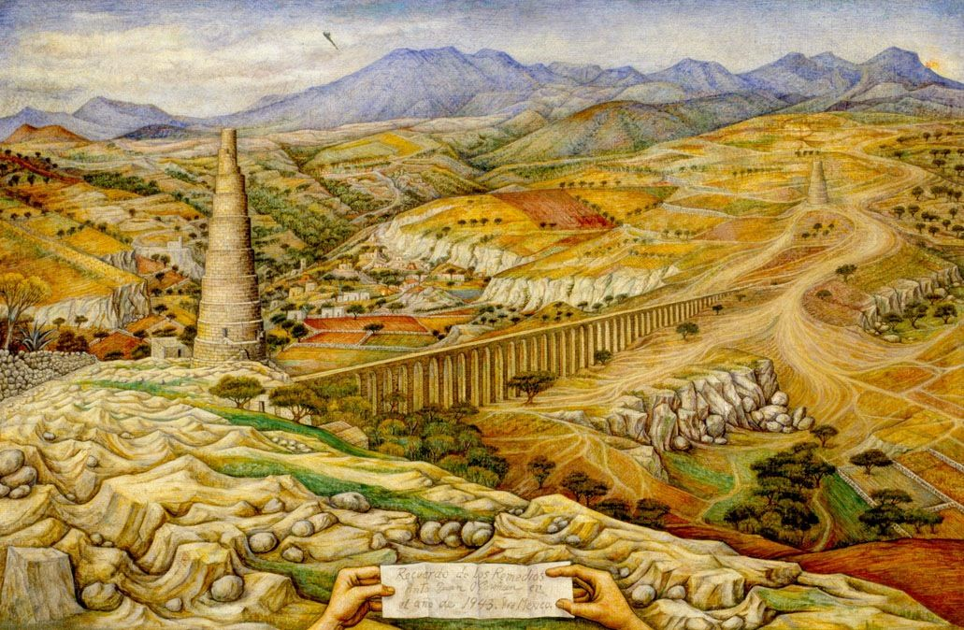
“Recuerdo de los remedios”. Tempera Painting.
1943.
http://munal.mx/munal/?page_id=900&pza_id=3049

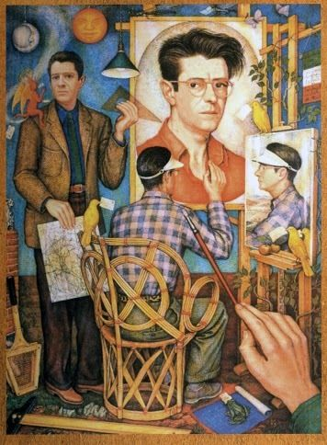
Self-portrait
1950
http://www.conaculta.gob.mx/detalle-nota/?id=10764

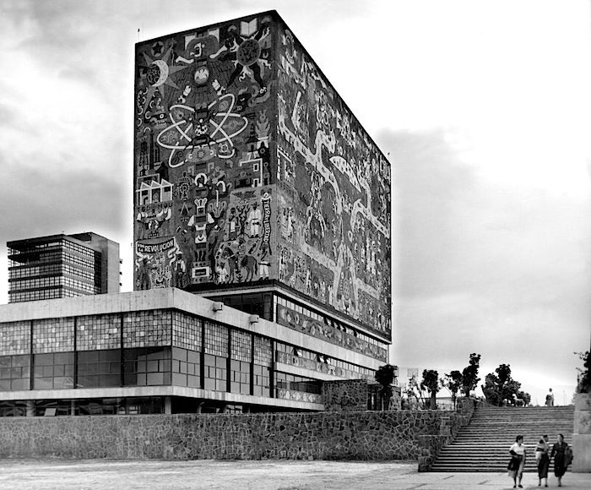
Central Library of the National Autonomous University Campus in the south of Mexico City.
1951
Copyright: Archivos de Arquitectos Mexicanos, UNAM
http://www.edgargonzalez.com/2010/02/01/mexico-moderno/

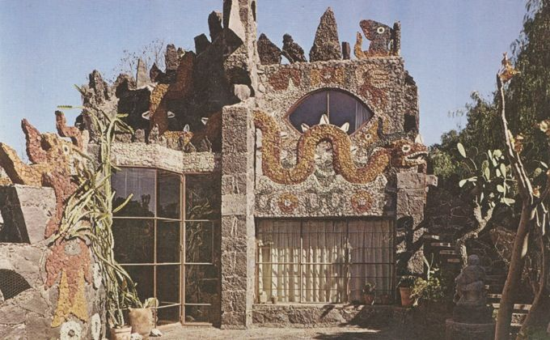
O’Gorman’s house San Jeronimo, San Angel, Mexico City, Mexico.
1952
http://www.revistacodigo.com/juan-o-gorman/

